 |  | Please write in the empty boxes
 | Name
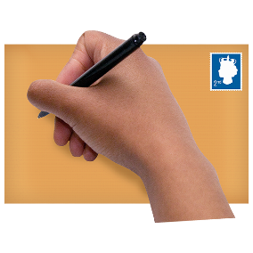 | Address
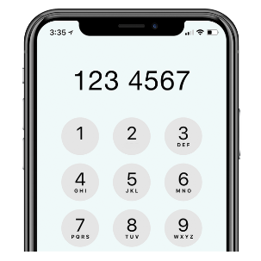 | Phone number
 | Email address
 | Are you over 18 years old?
Job History – please tell us about any jobs that you have had
Your job now or your last job
Job Title
What tasks did you do?
When did you start your job?
When did you leave your job?

Your previous job
Job Title
What tasks did you do?
When did you start your job?
When did you leave your job?

Why would you be good at this job?

Please tell us what you are good at that will help you do this job
It is important you tell us about all the things that will make you good at this job

Read the job pack to help you know what skills we are looking for
How to send your form

 | We must get your form by 10am on Friday 9th July
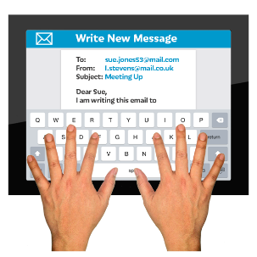 | You can email it to kara@bexleymencap.org.uk
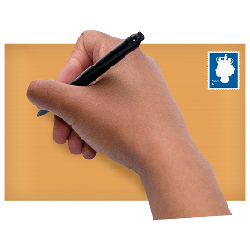 | You can post it to Bexley Mencap  19 Church Road  Bexleyheath  DA7 4DD
 | We will tell you by Friday 16th July if we want to interview you
We will keep your information safe on our computers

We will not share it with other people outside of Bexley Mencap or Ambient

